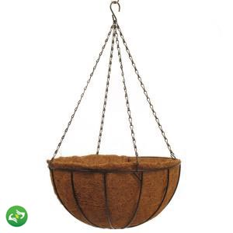
COCO BASKET
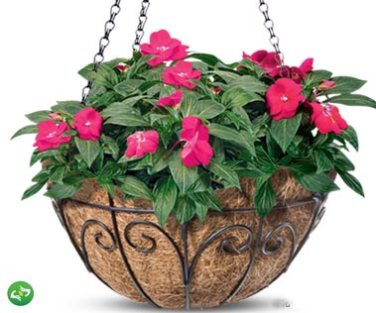
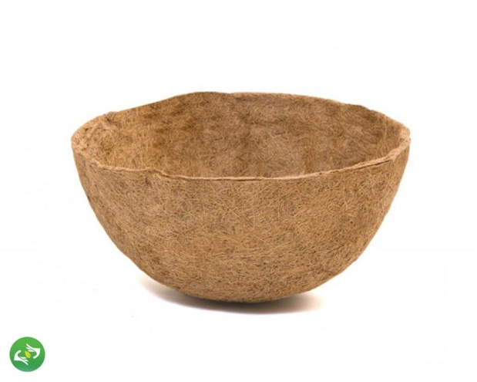

Specifications:
- Made out of coconut fibre
- Latex coated
- 10 and 12 inch diameter

Advantages:
- Can hold a great deal of water, releasing it slowly to allow plant roots to better take it up.
- Coconut liners also provide good drainage.
- They’re porous too, allowing for good aeration.
- These liners are very absorbent, so if hanging baskets or planters should become too dry, they will quickly re-absorb water.
- In addition, the organic material of coconut coir contains a neutral pH (6.0-6.7) and small amounts of beneficial phosphorus and potassium.
- Many coconut basket liners contain antifungal properties as well, which can help discourage disease.

