COCO PEAT
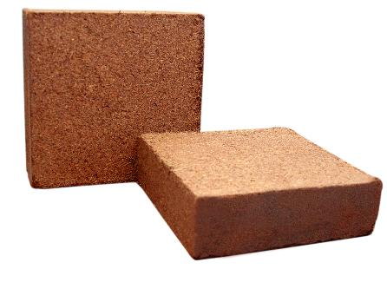
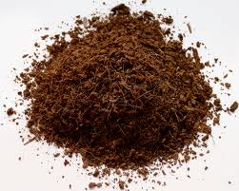

Specifications:
- Moisture 15-20%
- Organic Mater 85-90%
- Water Holding capacity more than 700
- pH 5.2 to 6.8
- E.C(ms/cm) <1

Advantages:
- 100% Organic
- Improves Aeration

