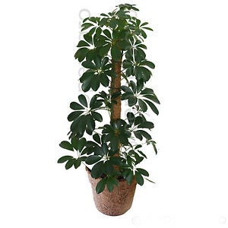
COCO POLE
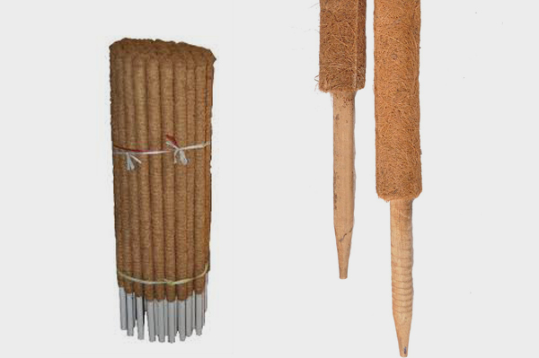

Specification:
- Height in 2,3,4,5 and 6 feet
- 10 mm latex coverage
- Latex covered on PVC pipe

Advantages:

- Can be used for creeper plants
- Plants can easily creep on the latex coated fibres
- Latex coating gives a long durability
- Keeps the pole moist and fungal free

